Hourglass
# Source: AI Source: Provided by: [Data Path: Persons Table -> ID Column: 1, Name_En Column: Motasem Essam] -> From: [ChatGPT] on [7/17/2026]
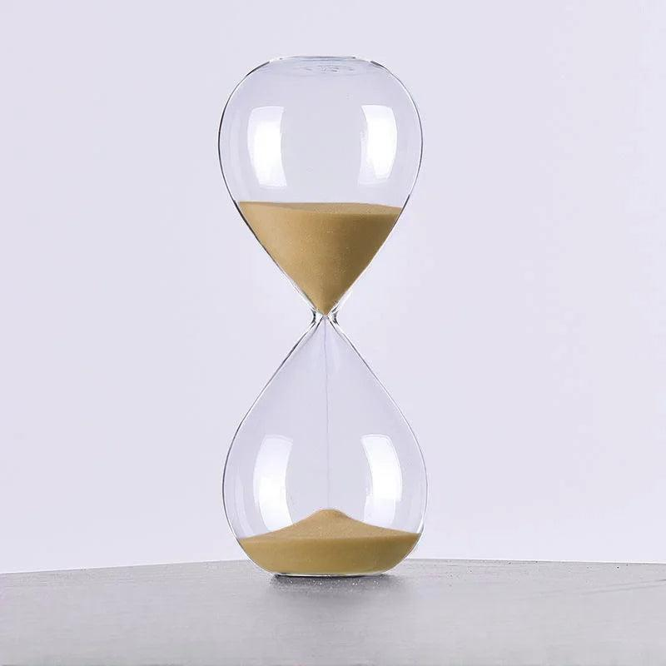
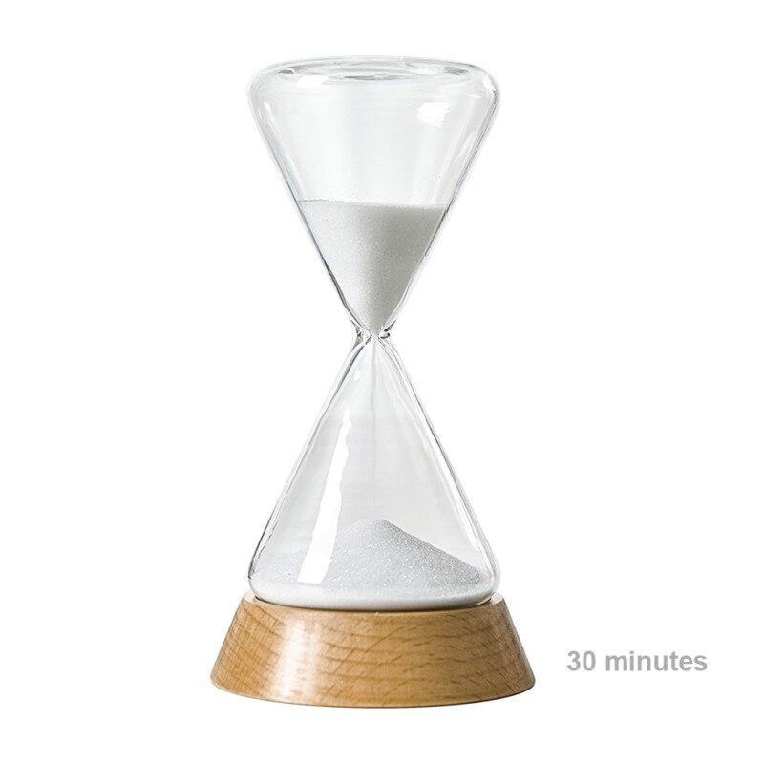
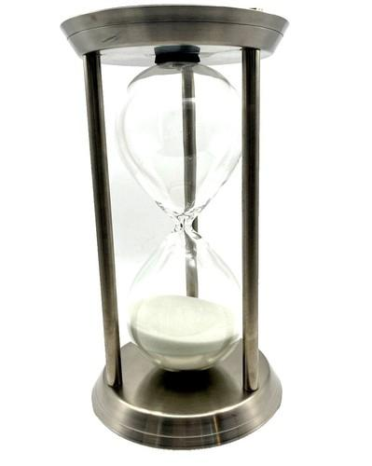
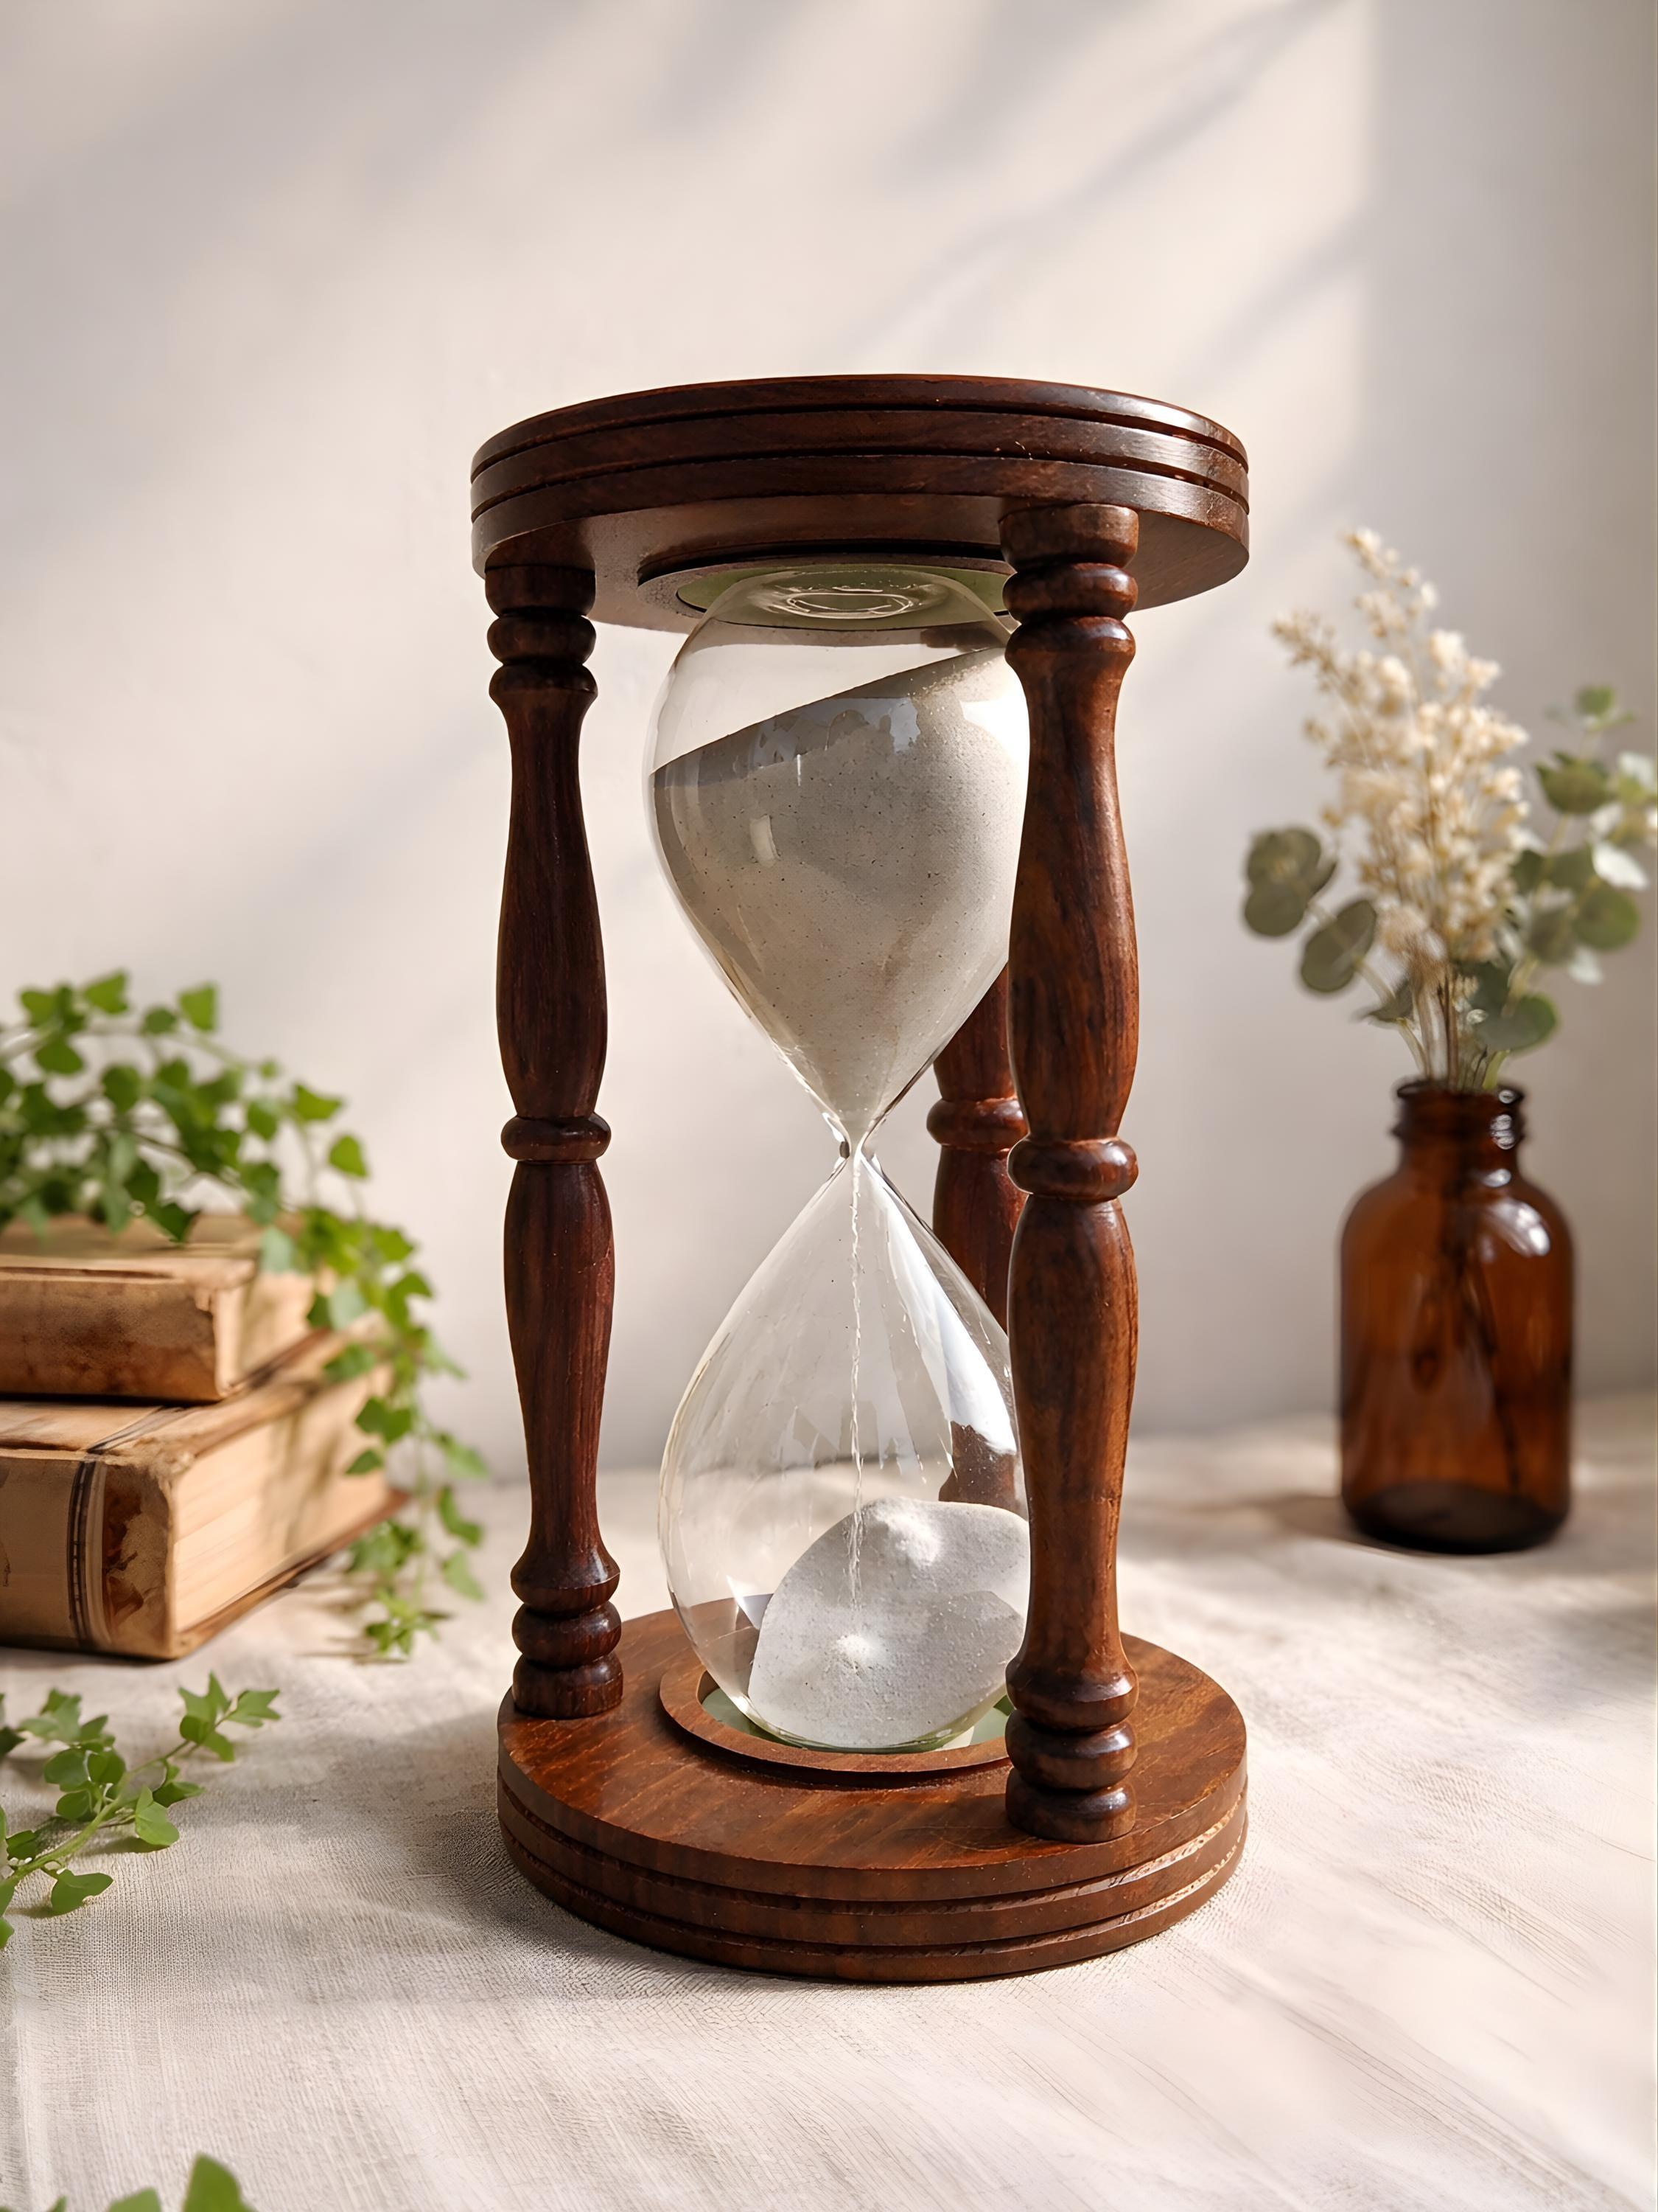
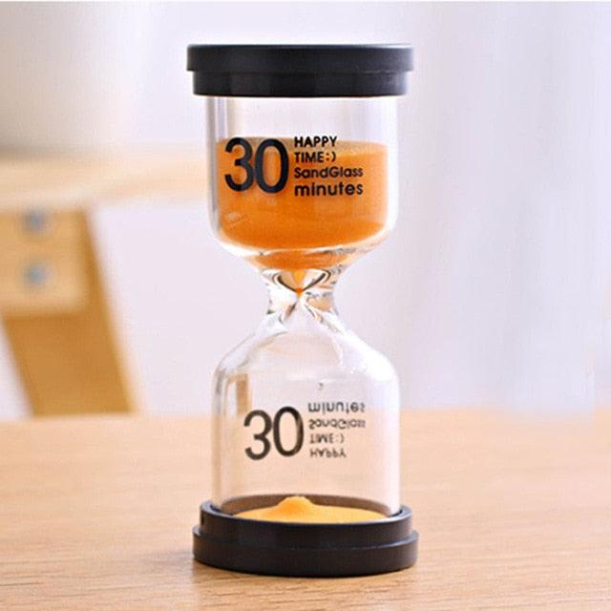
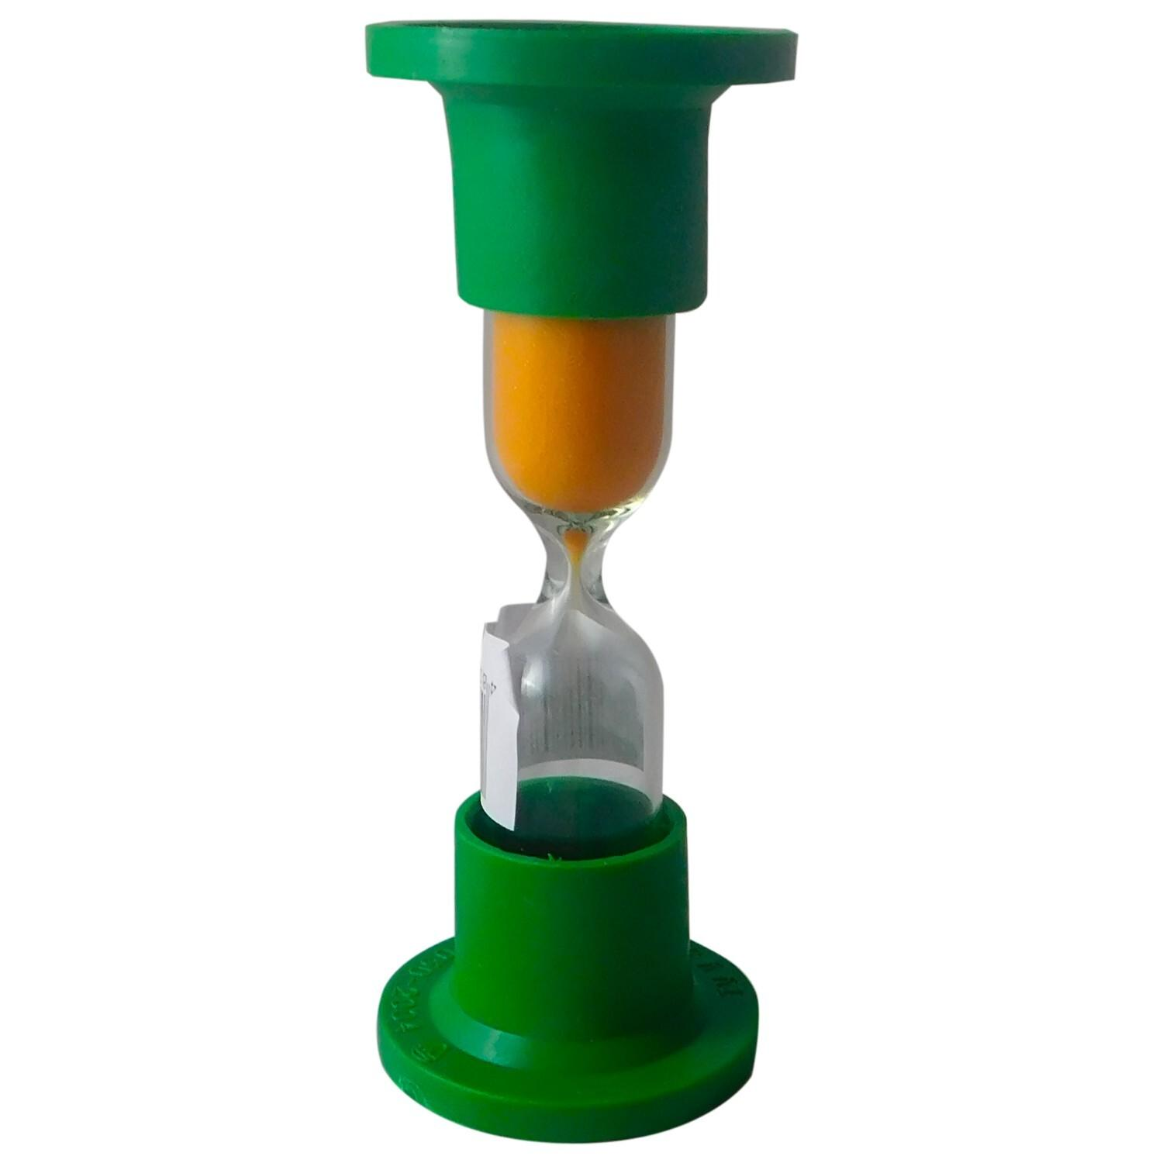
An Hourglass (also called a Sandglass or Sand Timer) is a time-measuring instrument that measures a fixed time interval by allowing a measured quantity of fine sand (or another granular material) to flow through a narrow opening between two connected glass bulbs.
It is one of the oldest portable time-measuring devices and has been used for navigation, cooking, religious ceremonies, scientific experiments, games, education, and decorative purposes.

Definition
# Source: AI Source: Provided by: [Data Path: Persons Table -> ID Column: 1, Name_En Column: Motasem Essam] -> From: [ChatGPT] on [7/17/2026]
An Hourglass is a mechanical time-measuring instrument that measures a fixed duration by allowing a calibrated amount of fine sand to flow from one glass chamber to another through a narrow passage.

Purpose
# Source: AI Source: Provided by: [Data Path: Persons Table -> ID Column: 1, Name_En Column: Motasem Essam] -> From: [ChatGPT] on [7/17/2026]
An hourglass is used to:
- Measure fixed time intervals.
- Time cooking processes.
- Time classroom activities.
- Conduct simple experiments.
- Time board games.
- Support meditation and relaxation.
- Serve as a decorative or historical timekeeping device.

Principle of Operation
# Source: AI Source: Provided by: [Data Path: Persons Table -> ID Column: 1, Name_En Column: Motasem Essam] -> From: [ChatGPT] on [7/17/2026]
An hourglass operates using gravity.
When the instrument is turned upside down:
- Sand flows through a narrow neck.
- The flow rate remains nearly constant under normal conditions.
- When all the sand reaches the lower chamber, the preset time has elapsed.
Unlike a clock, an hourglass does not display the current time—it measures only a fixed duration.

Main Components
# Source: AI Source: Provided by: [Data Path: Persons Table -> ID Column: 1, Name_En Column: Motasem Essam] -> From: [ChatGPT] on [7/17/2026]
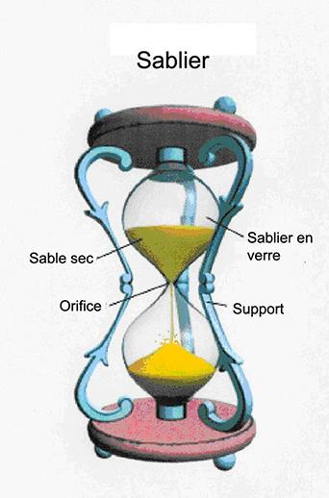
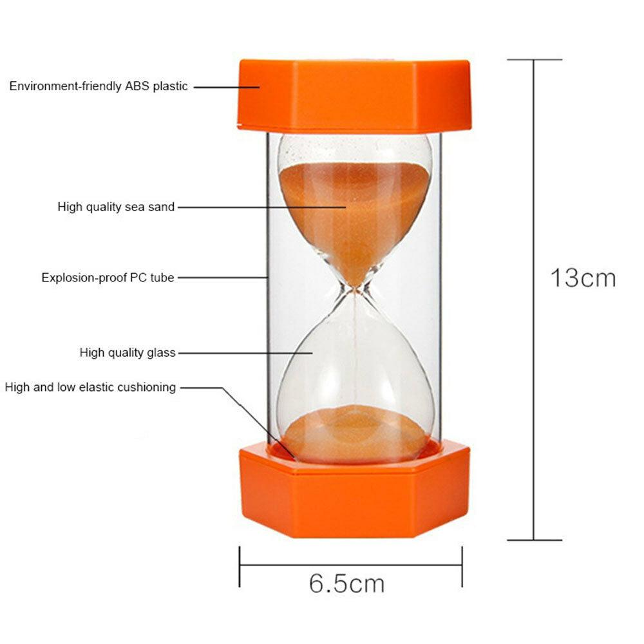
A typical hourglass consists of:
- Upper glass bulb
- Lower glass bulb
- Narrow neck (orifice)
- Fine sand or other granular material
- Protective frame (wood, metal, or plastic)

Types of Hourglasses

1. Sand Hourglass
# Source: AI Source: Provided by: [Data Path: Persons Table -> ID Column: 1, Name_En Column: Motasem Essam] -> From: [ChatGPT] on [7/17/2026]
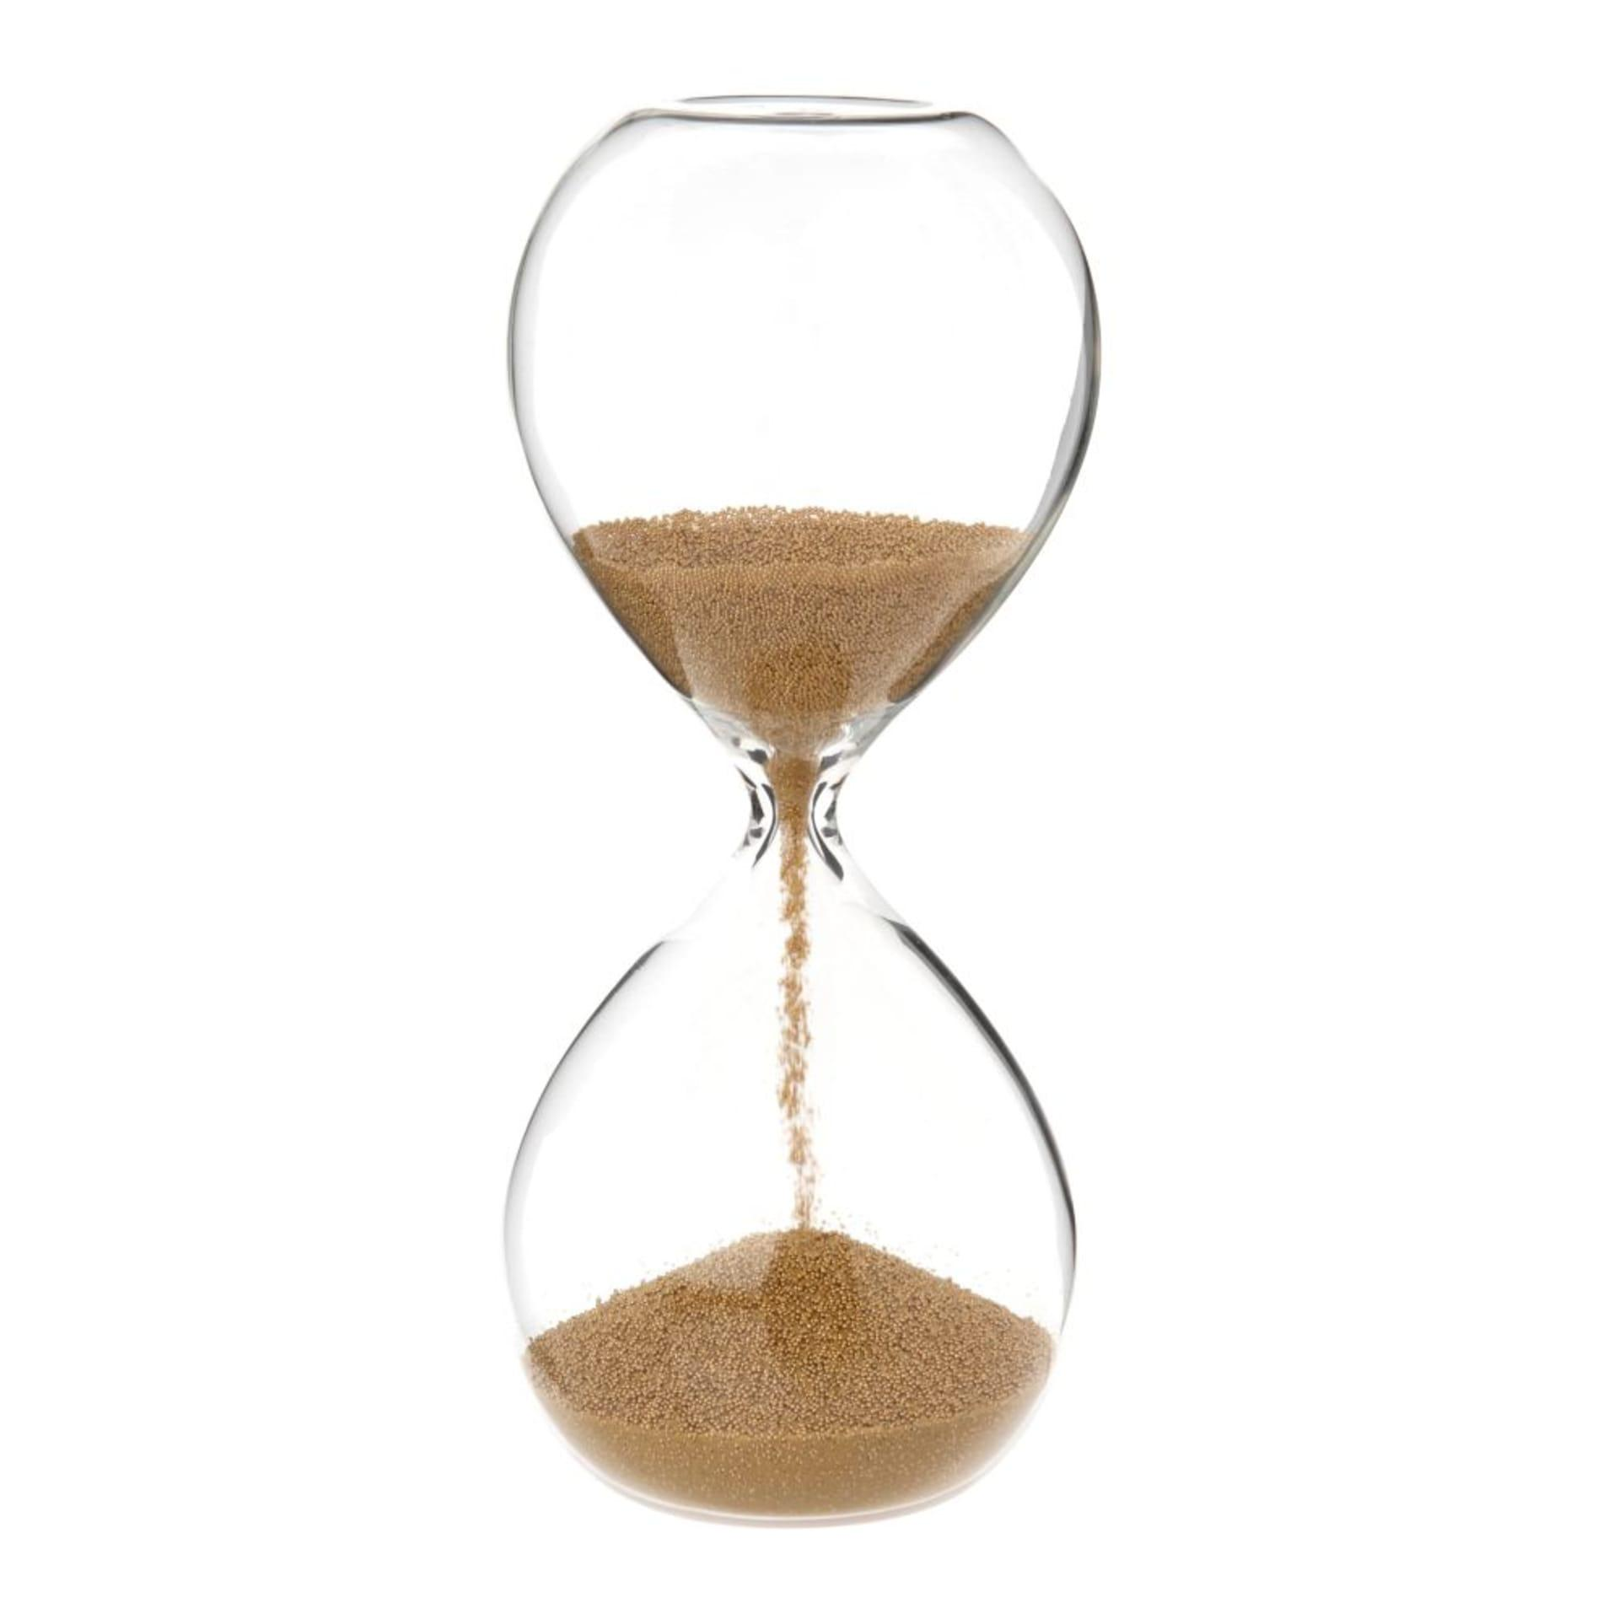
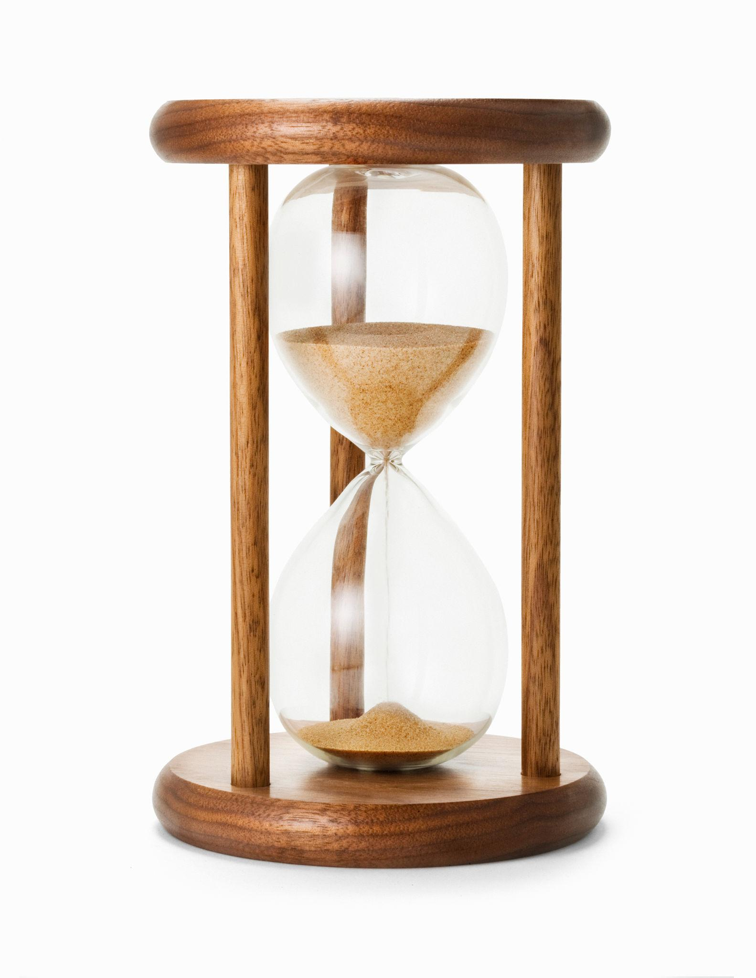
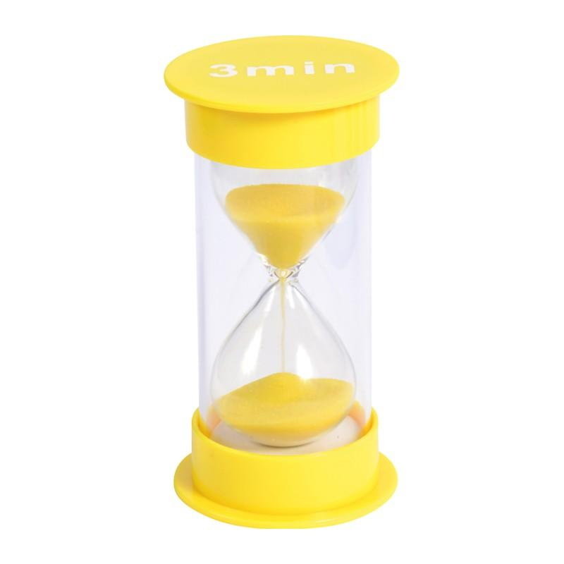
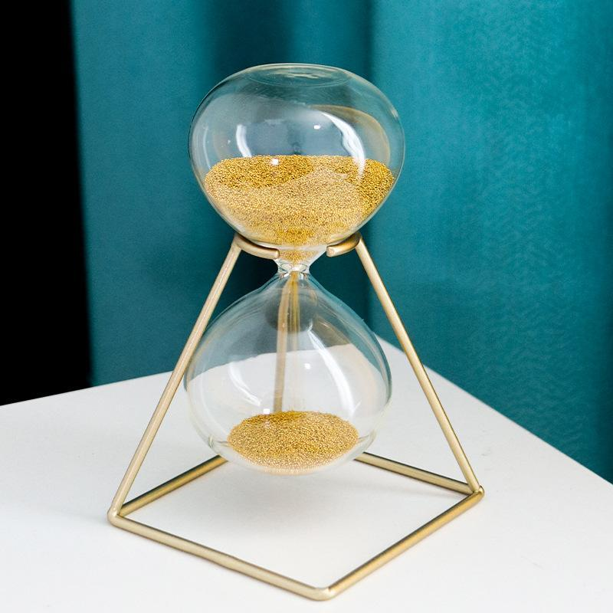
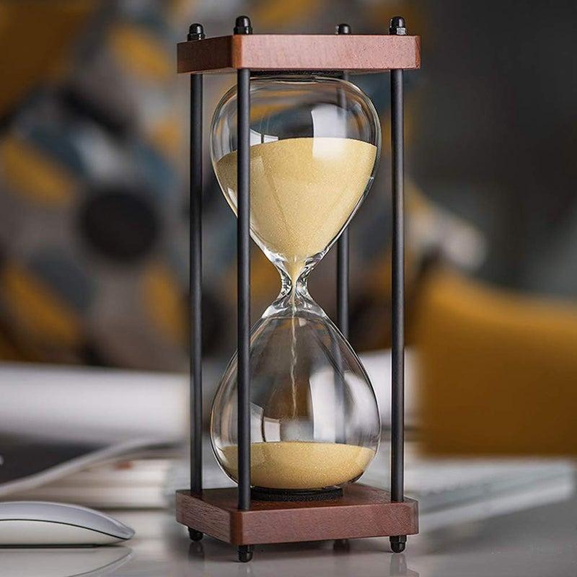
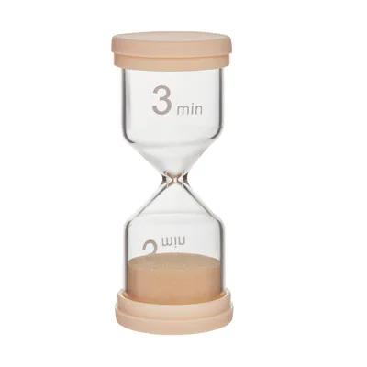
Description
The traditional hourglass filled with fine sand.
Applications
- Education
- Decoration
- Timing short activities

2. Decorative Hourglass
# Source: AI Source: Provided by: [Data Path: Persons Table -> ID Column: 1, Name_En Column: Motasem Essam] -> From: [ChatGPT] on [7/17/2026]

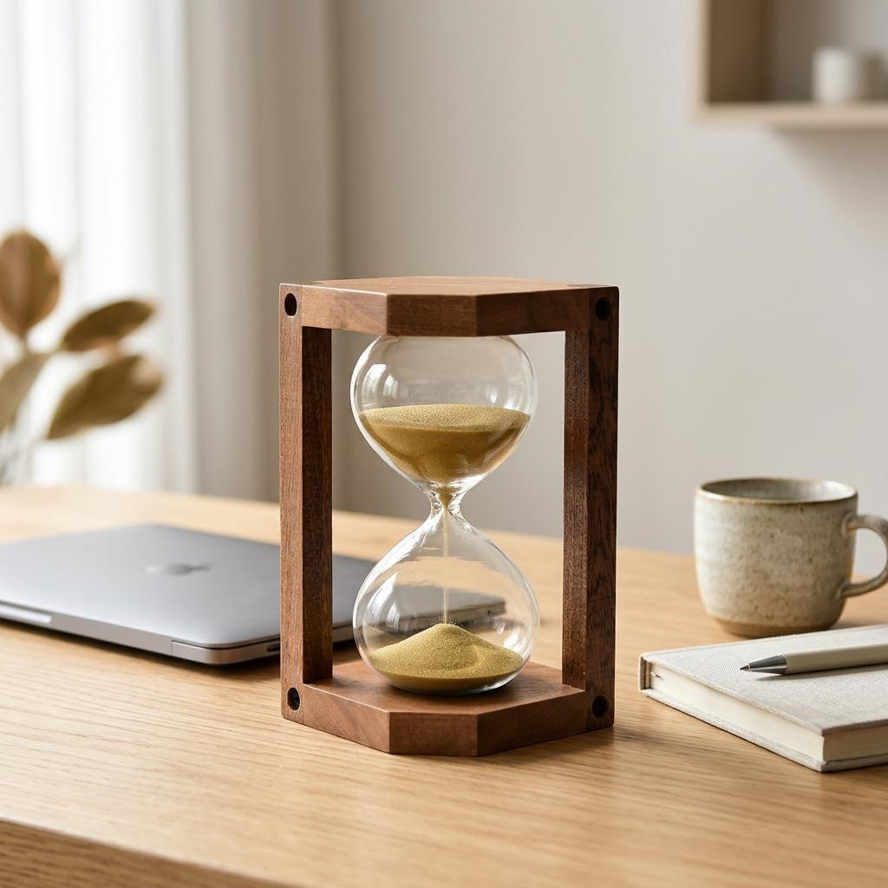
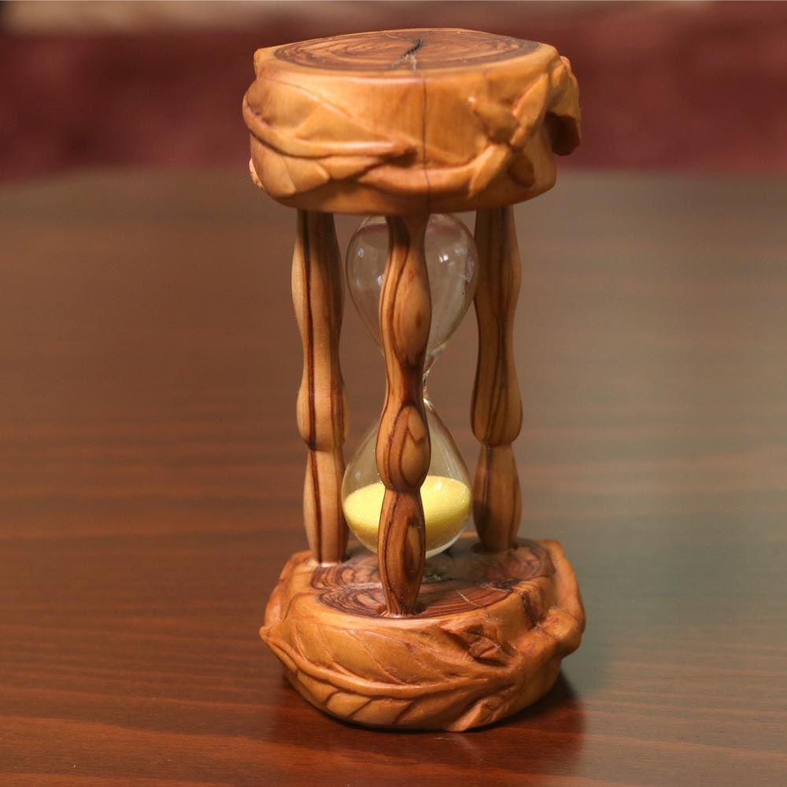
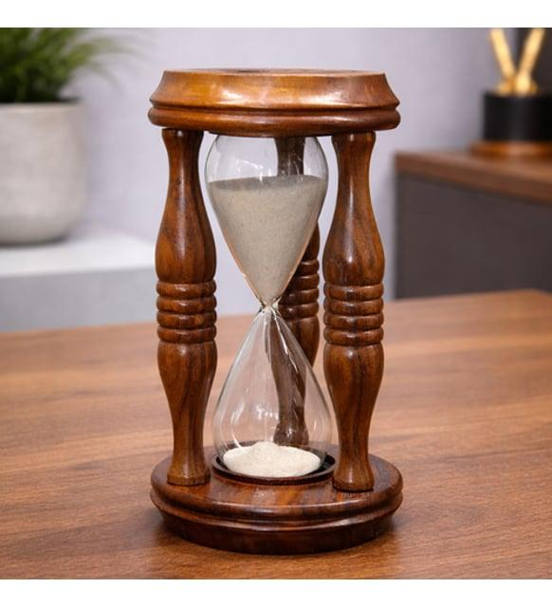
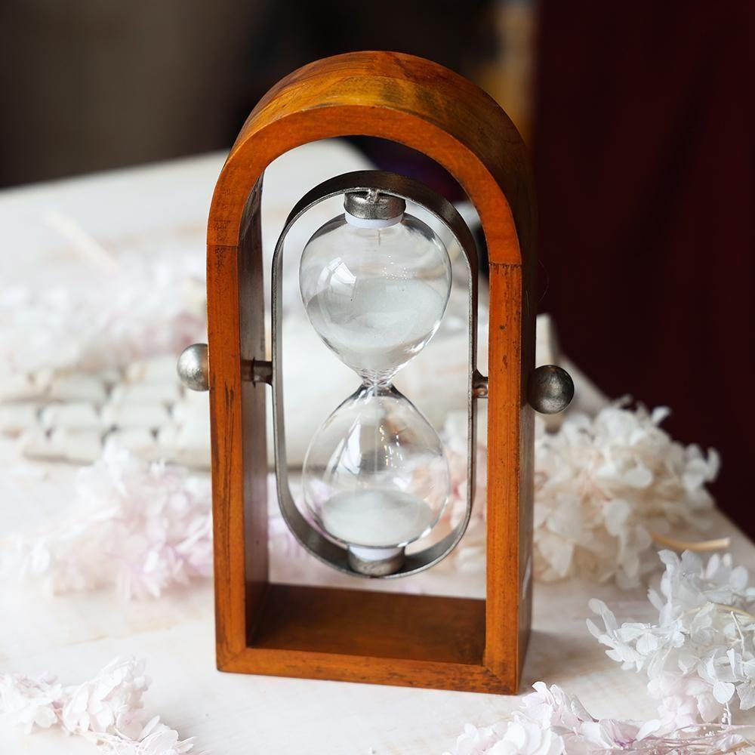
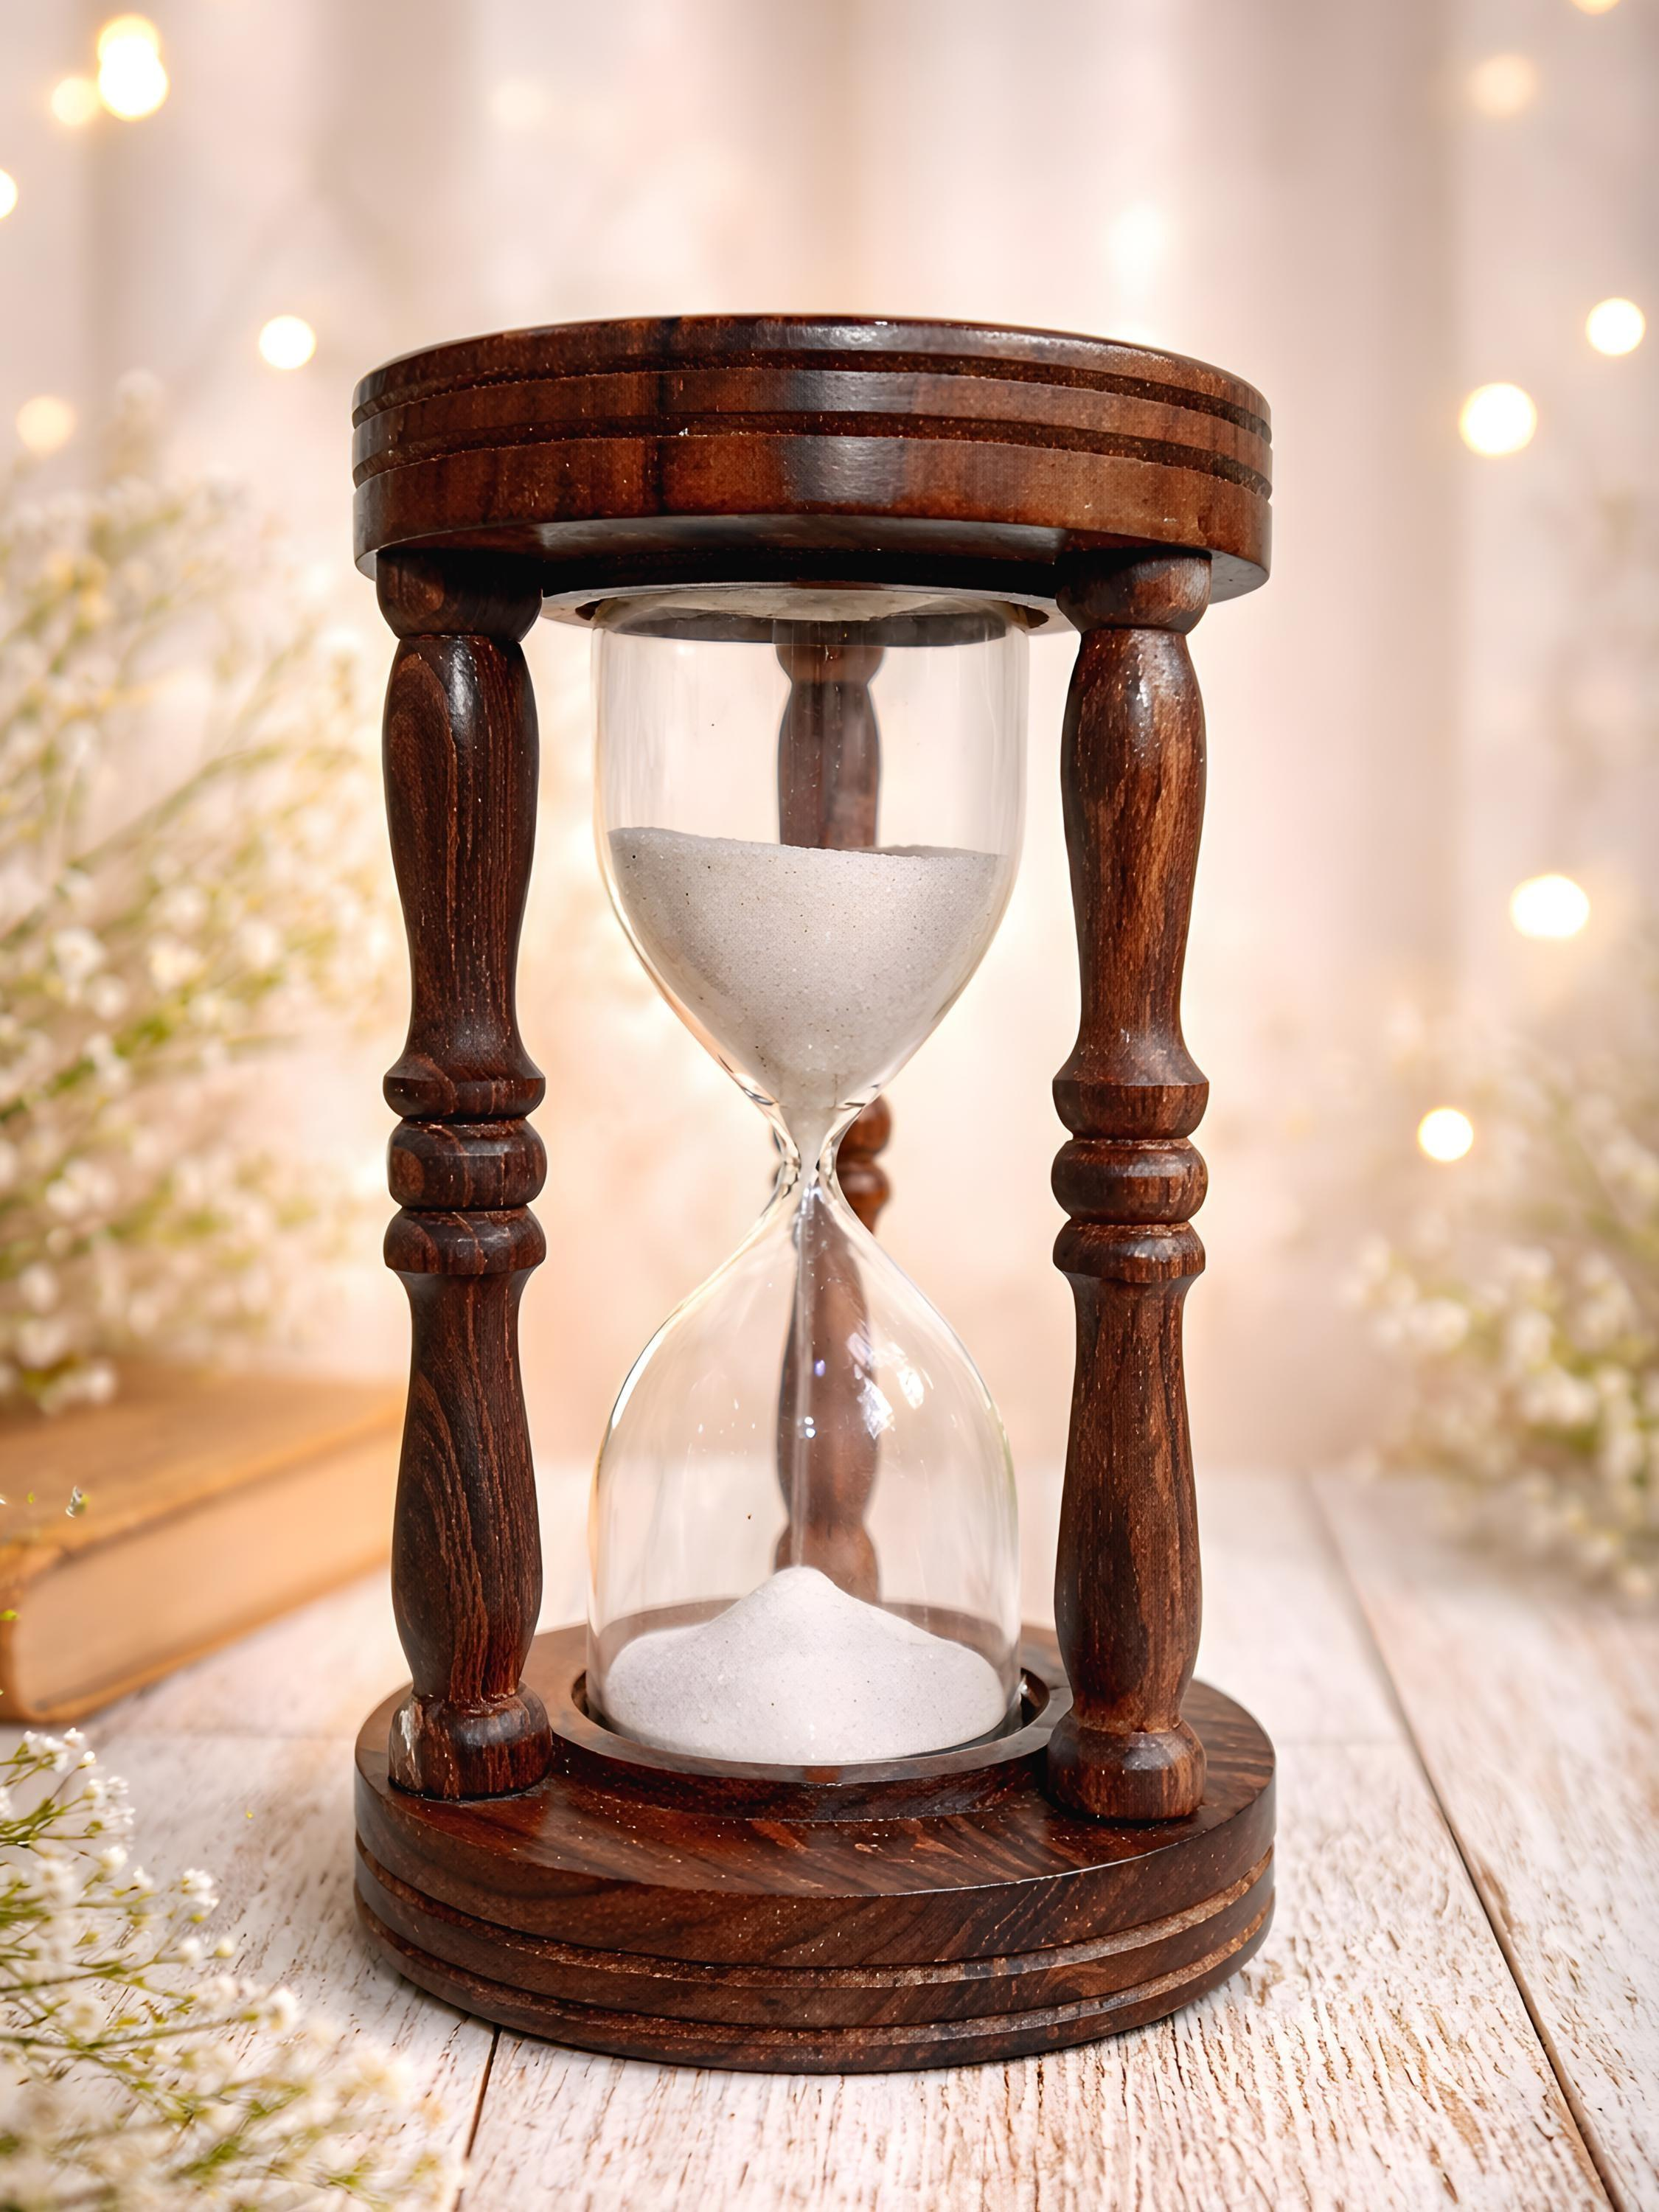
Description
Designed primarily for aesthetic purposes while remaining functional.
Applications
- Home decoration
- Offices
- Gifts

3. Laboratory Sand Timer
# Source: AI Source: Provided by: [Data Path: Persons Table -> ID Column: 1, Name_En Column: Motasem Essam] -> From: [ChatGPT] on [7/17/2026]


Description
A calibrated hourglass used for educational demonstrations or simple laboratory timing.
Applications
- Schools
- Laboratories
- Science demonstrations

4. Colored Sand Hourglass
# Source: AI Source: Provided by: [Data Path: Persons Table -> ID Column: 1, Name_En Column: Motasem Essam] -> From: [ChatGPT] on [7/17/2026]
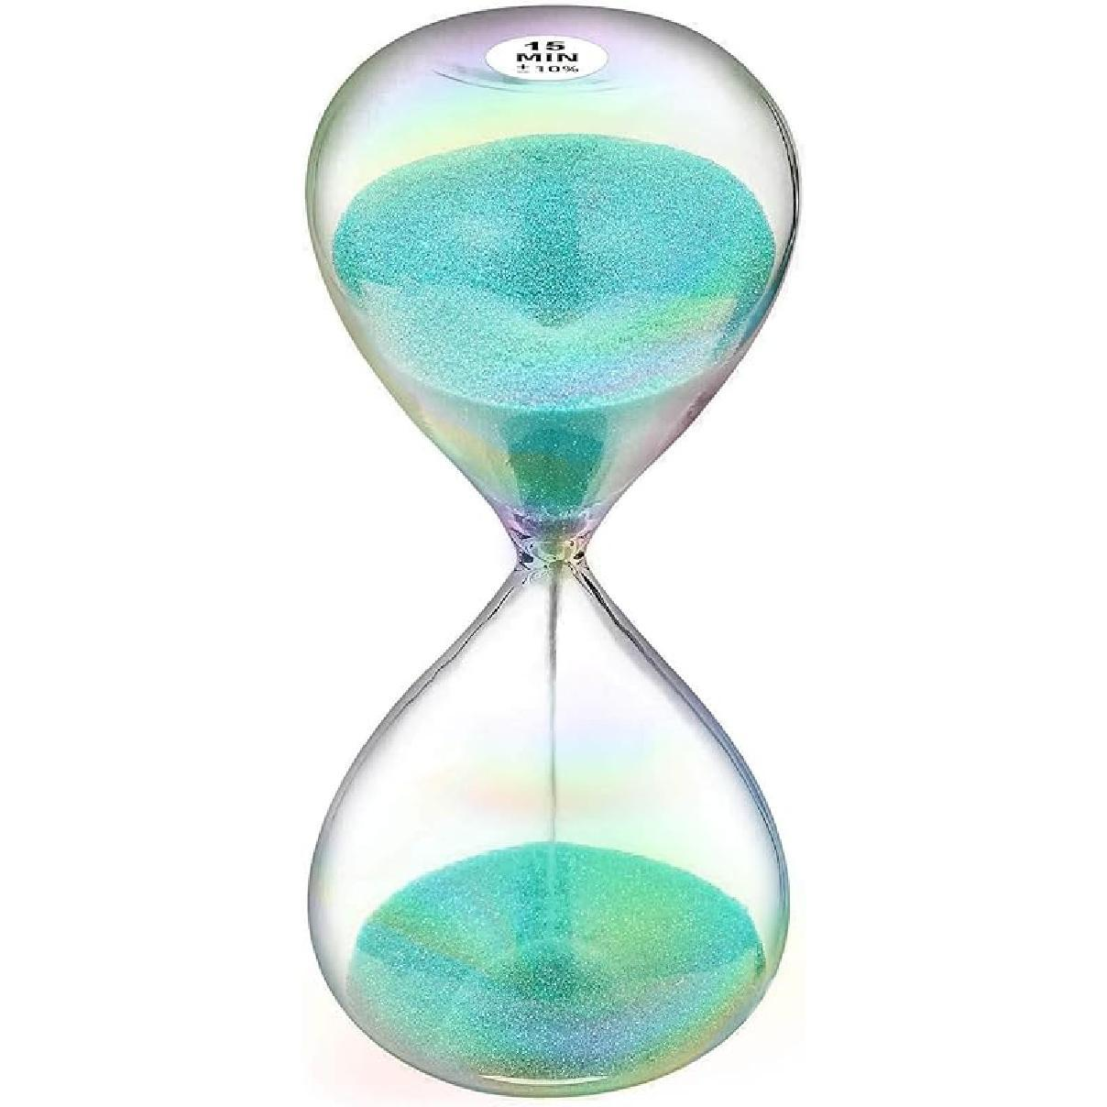
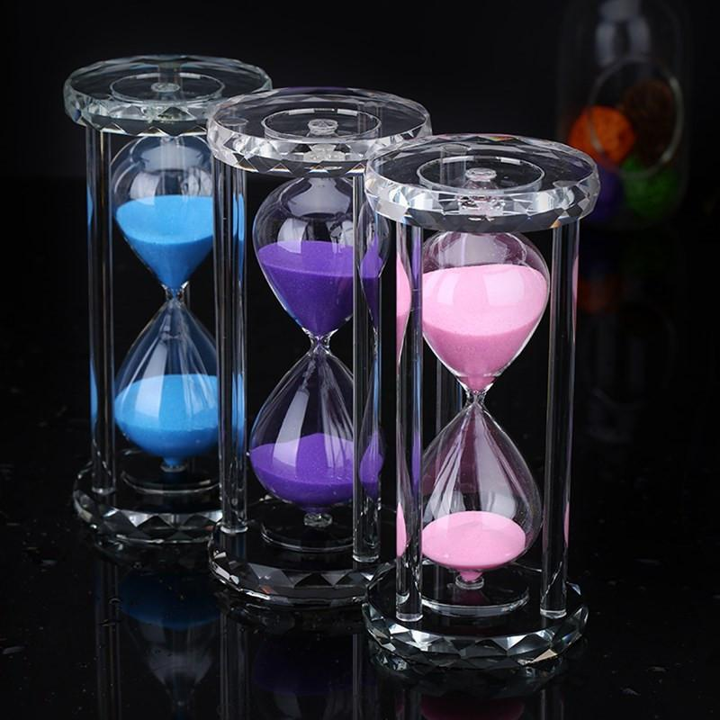
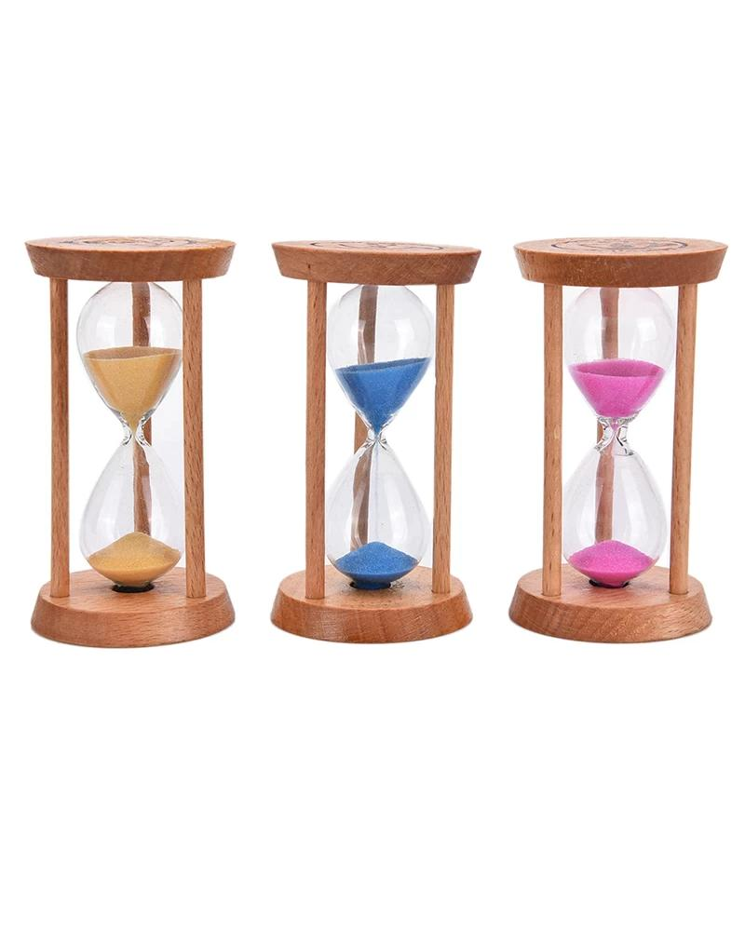
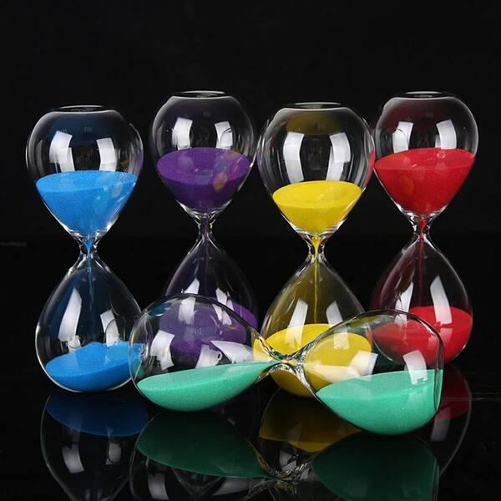
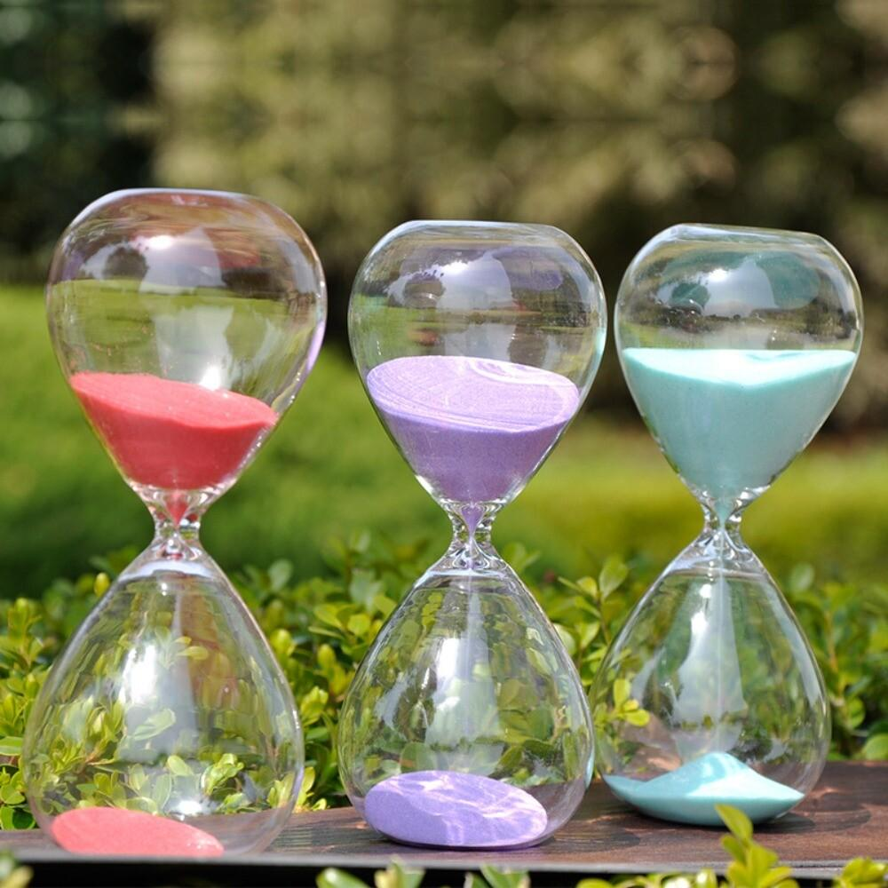
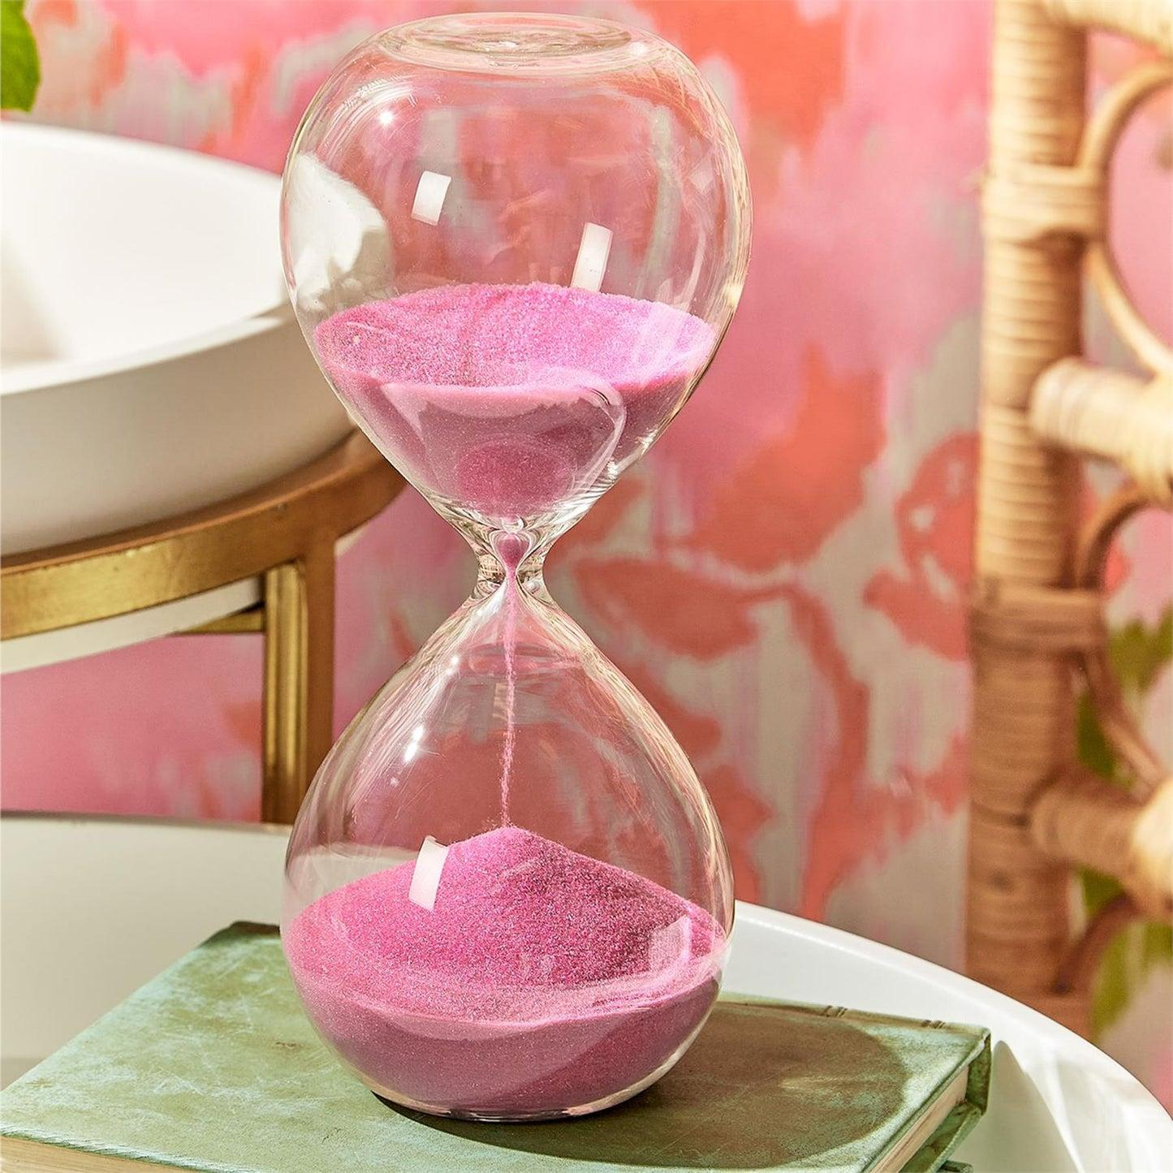
Description
Uses colored sand for improved visibility and decorative appeal.
Applications
- Educational tools
- Children's activities
- Decoration

Common Time Intervals
# Source: AI Source: Provided by: [Data Path: Persons Table -> ID Column: 1, Name_En Column: Motasem Essam] -> From: [ChatGPT] on [7/17/2026]
Hourglasses are manufactured for fixed durations such as:
- 30 seconds
- 1 minute
- 2 minutes
- 3 minutes
- 5 minutes
- 10 minutes
- 15 minutes
- 30 minutes
- 60 minutes

Measuring Units
An hourglass measures:
- Seconds (s)
- Minutes (min)
- Hours (h) (large models)

Measuring Range
# Source: AI Source: Provided by: [Data Path: Persons Table -> ID Column: 1, Name_En Column: Motasem Essam] -> From: [ChatGPT] on [7/17/2026]
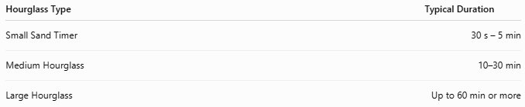
Hourglass Type | Typical Duration
Small Sand Timer | 30 s – 5 min
Medium Hourglass | 10–30 min
Large Hourglass | Up to 60 min or more

Resolution
# Source: AI Source: Provided by: [Data Path: Persons Table -> ID Column: 1, Name_En Column: Motasem Essam] -> From: [ChatGPT] on [7/17/2026]
The resolution depends on the total duration and the observer.
Typical practical resolution is approximately:
- 1 second for short-duration timers
- Lower precision for longer timers
Hourglasses are not intended for high-precision timing.

How to Use an Hourglass
# Source: AI Source: Provided by: [Data Path: Persons Table -> ID Column: 1, Name_En Column: Motasem Essam] -> From: [ChatGPT] on [7/17/2026]
- Place the hourglass upright.
- Turn it upside down.
- Allow the sand to flow naturally.
- Observe when the upper chamber becomes empty.
- The preset time interval has now elapsed.

Example
# Source: AI Source: Provided by: [Data Path: Persons Table -> ID Column: 1, Name_En Column: Motasem Essam] -> From: [ChatGPT] on [7/17/2026]
A 5-minute hourglass is turned over.
When all the sand reaches the lower chamber:
Elapsed time = 5 minutes

Accuracy
# Source: AI Source: Provided by: [Data Path: Persons Table -> ID Column: 1, Name_En Column: Motasem Essam] -> From: [ChatGPT] on [7/17/2026]
Accuracy depends on:
- Uniform grain size
- Neck diameter
- Humidity
- Manufacturing precision
- Orientation during use
Modern hourglasses are generally suitable for approximate timing rather than precision measurement.

Sources of Error
# Source: AI Source: Provided by: [Data Path: Persons Table -> ID Column: 1, Name_En Column: Motasem Essam] -> From: [ChatGPT] on [7/17/2026]
Instrument Errors
- Worn or damaged glass
- Incorrect calibration
- Irregular sand grain size

Environmental Errors
- Humidity causing sand to clump
- Static electricity
- Vibration
- Uneven positioning

User Errors
- Not turning the hourglass completely.
- Tilting the hourglass while operating.
- Starting observation late.

Applications
# Source: AI Source: Provided by: [Data Path: Persons Table -> ID Column: 1, Name_En Column: Motasem Essam] -> From: [ChatGPT] on [7/17/2026]
Hourglasses are used in:
- Cooking
- Board games
- Classrooms
- Laboratories
- Meditation
- Public speaking
- Decorative displays
- Museums
- Historical demonstrations

Advantages
# Source: AI Source: Provided by: [Data Path: Persons Table -> ID Column: 1, Name_En Column: Motasem Essam] -> From: [ChatGPT] on [7/17/2026]
An hourglass:
- Requires no electricity.
- Is simple to operate.
- Is portable.
- Works anywhere under normal gravity.
- Has no batteries or electronics.
- Is durable and long-lasting.

Limitations
# Source: AI Source: Provided by: [Data Path: Persons Table -> ID Column: 1, Name_En Column: Motasem Essam] -> From: [ChatGPT] on [7/17/2026]
An hourglass:
- Measures only one fixed interval.
- Cannot display the current time.
- Is less accurate than modern clocks or digital timers.
- Must be manually turned over to restart timing.
- Performance can be affected by humidity and sand condition.

Comparison with Other Time Measuring Instruments
# Source: AI Source: Provided by: [Data Path: Persons Table -> ID Column: 1, Name_En Column: Motasem Essam] -> From: [ChatGPT] on [7/17/2026]
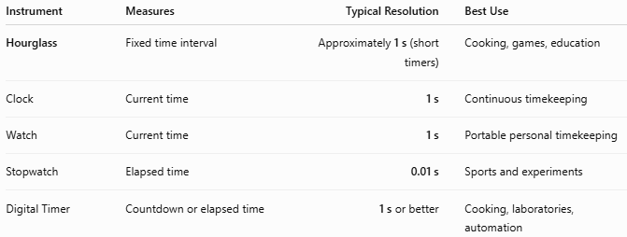
Instrument | Measures | Typical Resolution | Best Use
Hourglass | Fixed time interval | Approximately 1 s (short timers) | Cooking, games, education
Clock | Current time | 1 s | Continuous timekeeping
Watch | Current time | 1 s | Portable personal timekeeping
Stopwatch | Elapsed time | 0.01 s | Sports and experiments
Digital Timer | Countdown or elapsed time | 1 s or better | Cooking, laboratories, automation

Care and Maintenance
# Source: AI Source: Provided by: [Data Path: Persons Table -> ID Column: 1, Name_En Column: Motasem Essam] -> From: [ChatGPT] on [7/17/2026]
To maintain reliable operation:
- Keep the glass clean.
- Avoid dropping the hourglass.
- Store in a dry environment.
- Protect from excessive humidity.
- Keep the instrument upright when not in use.

Common Mistakes
# Source: AI Source: Provided by: [Data Path: Persons Table -> ID Column: 1, Name_En Column: Motasem Essam] -> From: [ChatGPT] on [7/17/2026]
- Assuming the hourglass measures the current time.
- Using it for precision scientific timing.
- Tilting the hourglass during operation.
- Ignoring the effects of humidity on sand flow.

Key Points
# Source: AI Source: Provided by: [Data Path: Persons Table -> ID Column: 1, Name_En Column: Motasem Essam] -> From: [ChatGPT] on [7/17/2026]
- An Hourglass measures a fixed time interval.
- It works by allowing sand to flow under gravity through a narrow neck.
- Common types:
  - Sand Hourglass
  - Decorative Hourglass
  - Laboratory Sand Timer
  - Colored Sand Hourglass
- Typical durations range from 30 seconds to 60 minutes.
- It is widely used in education, cooking, games, laboratories, and decoration.

Conclusion
# Source: AI Source: Provided by: [Data Path: Persons Table -> ID Column: 1, Name_En Column: Motasem Essam] -> From: [ChatGPT] on [7/17/2026]
The Hourglass is one of the oldest and simplest time-measuring instruments, relying solely on gravity and the controlled flow of sand to measure a predetermined time interval. Although modern digital timers and stopwatches offer far greater precision and flexibility, the hourglass remains valuable for educational demonstrations, timing routine activities, historical reenactments, and decorative purposes due to its simplicity, reliability, and independence from batteries or electrical power.

